Bahria University,

Karachi Campus



LAB EXPERIMENT NO.

**07**

LIST OF TASKS

|  |  |
| --- | --- |
| TASK NO | OBJECTIVE |
| 1 | **Write a python program implementing the Newton's forward/backward differentiation method to find first order derivative, when  a. x = 1.1  b. x= 1.6** |

**Task 1: Write a python program implementing the Newton's forward/backward differentiation method to find first order derivative, when a. x = 1.1 b. x= 1.6**

**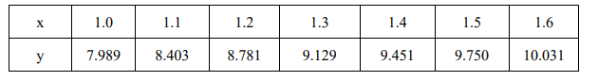  
Solution  
a. x = 1.1**

**b. x= 1.6**

